HW 09

TUAN BUI

11/23/2021

library(tidyverse)

## ── Attaching packages ─────────────────────────────────────── tidyverse 1.3.1 ──

## ✓ ggplot2 3.3.5 ✓ purrr 0.3.4  
## ✓ tibble 3.1.4 ✓ dplyr 1.0.7  
## ✓ tidyr 1.1.3 ✓ stringr 1.4.0  
## ✓ readr 2.0.1 ✓ forcats 0.5.1

## ── Conflicts ────────────────────────────────────────── tidyverse_conflicts() ──  
## x dplyr::filter() masks stats::filter()  
## x dplyr::lag() masks stats::lag()

library(caret)

## Loading required package: lattice

##   
## Attaching package: 'caret'

## The following object is masked from 'package:purrr':  
##   
## lift

library(neuralnet)

##   
## Attaching package: 'neuralnet'

## The following object is masked from 'package:dplyr':  
##   
## compute

titanic_data <- read.csv('~/OneDrive - Stony Brook University/SBU/MAT + AMS/Fall 2021/AMS 380/hw/09/Titanic.csv', header = T)

# Question 01

titanic_data <- subset(titanic_data, select = -c(PassengerId, Name, Ticket, Cabin))  
  
titanic_data <- na.omit(titanic_data)  
str(titanic_data)

## 'data.frame': 714 obs. of 8 variables:  
## $ Survived: int 0 1 1 1 0 0 0 1 1 1 ...  
## $ Pclass : int 3 1 3 1 3 1 3 3 2 3 ...  
## $ Sex : chr "male" "female" "female" "female" ...  
## $ Age : num 22 38 26 35 35 54 2 27 14 4 ...  
## $ SibSp : int 1 1 0 1 0 0 3 0 1 1 ...  
## $ Parch : int 0 0 0 0 0 0 1 2 0 1 ...  
## $ Fare : num 7.25 71.28 7.92 53.1 8.05 ...  
## $ Embarked: chr "S" "C" "S" "S" ...  
## - attr(*, "na.action")= 'omit' Named int [1:177] 6 18 20 27 29 30 32 33 37 43 ...  
## ..- attr(*, "names")= chr [1:177] "6" "18" "20" "27" ...

# There are 714 observations left after omitting the missing data  
  
x <- model.matrix(Survived ~ ., data = titanic_data)  
titanic_data <- cbind(x[,-1], Survived = titanic_data$Survived)  
titanic_data <- as.data.frame(titanic_data)  
  
# Generate training and testing data  
set.seed(123)  
training.samples <- titanic_data$Survived %>%   
 createDataPartition(p = 0.75, list = FALSE)  
train.data <- titanic_data[training.samples, ]  
test.data <- titanic_data[-training.samples, ]

# Question 02

set.seed(123)  
model_02 <- neuralnet(Survived ~ ., data = train.data, hidden = 0, err.fct = "sse", linear.output = F)  
  
plot(model_02, rep = "best")

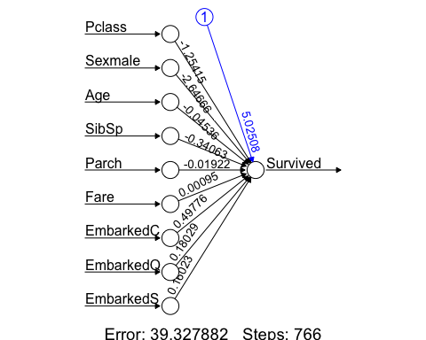

probabilities_02 <- model_02 %>% predict(test.data) %>% as.vector()  
predicted.classes_02 <- ifelse(probabilities_02 > 0.5, 1, 0)  
confusionMatrix(factor(predicted.classes_02), factor(test.data$Survived), positive = '1')

## Confusion Matrix and Statistics  
##   
## Reference  
## Prediction 0 1  
## 0 89 21  
## 1 9 59  
##   
## Accuracy : 0.8315   
## 95% CI : (0.7682, 0.8833)  
## No Information Rate : 0.5506   
## P-Value [Acc > NIR] : 2.015e-15   
##   
## Kappa : 0.6547   
##   
## Mcnemar's Test P-Value : 0.04461   
##   
## Sensitivity : 0.7375   
## Specificity : 0.9082   
## Pos Pred Value : 0.8676   
## Neg Pred Value : 0.8091   
## Prevalence : 0.4494   
## Detection Rate : 0.3315   
## Detection Prevalence : 0.3820   
## Balanced Accuracy : 0.8228   
##   
## 'Positive' Class : 1   
##

# confusion matrix  
table(predicted.classes_02, test.data$Survived)

##   
## predicted.classes_02 0 1  
## 0 89 21  
## 1 9 59

# The overall accuracy of the test data is 0.8315  
# The sensitivity of the test data is 0.7375  
# The specificity of the test data is 0.9082

# Question 03

set.seed(123)  
model_03 <- neuralnet(Survived ~ ., data = train.data, hidden = 0, err.fct = "ce", linear.output = F)  
plot(model_03, rep = "best")

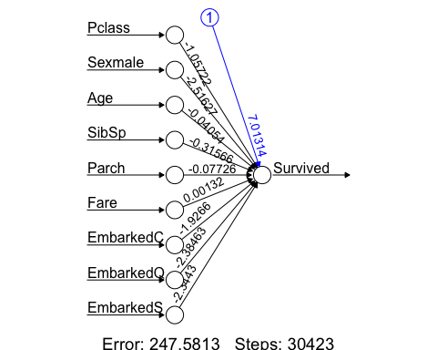

probabilities_03 <- model_03 %>% predict(test.data) %>% as.vector()  
predicted.classes_03 <- ifelse(probabilities_03 > 0.5, 1, 0)  
confusionMatrix(factor(predicted.classes_03), factor(test.data$Survived), positive = '1')

## Confusion Matrix and Statistics  
##   
## Reference  
## Prediction 0 1  
## 0 89 21  
## 1 9 59  
##   
## Accuracy : 0.8315   
## 95% CI : (0.7682, 0.8833)  
## No Information Rate : 0.5506   
## P-Value [Acc > NIR] : 2.015e-15   
##   
## Kappa : 0.6547   
##   
## Mcnemar's Test P-Value : 0.04461   
##   
## Sensitivity : 0.7375   
## Specificity : 0.9082   
## Pos Pred Value : 0.8676   
## Neg Pred Value : 0.8091   
## Prevalence : 0.4494   
## Detection Rate : 0.3315   
## Detection Prevalence : 0.3820   
## Balanced Accuracy : 0.8228   
##   
## 'Positive' Class : 1   
##

# confusion matrix  
table(predicted.classes_03, test.data$Survived)

##   
## predicted.classes_03 0 1  
## 0 89 21  
## 1 9 59

# The overall accuracy of the test data is 0.8315  
# The sensitivity of the test data is 0.7375  
# The specificity of the test data is 0.9082

# Question 04

set.seed(123)  
model_04 <- glm(Survived ~ ., family = binomial, data = train.data)  
# The fitted logistic regression model coefficients obtained using the training data:  
summary(model_04)$coefficients

## Estimate Std. Error z value Pr(>|z|)  
## (Intercept) 16.061380335 5.354114e+02 0.02999820 9.760685e-01  
## Pclass -1.057949923 1.786500e-01 -5.92191475 3.182146e-09  
## Sexmale -2.516036754 2.467277e-01 -10.19762748 2.031750e-24  
## Age -0.040580904 9.053326e-03 -4.48243050 7.379768e-06  
## SibSp -0.315739290 1.437562e-01 -2.19635243 2.806673e-02  
## Parch -0.077049121 1.317589e-01 -0.58477376 5.586999e-01  
## Fare 0.001308881 2.558554e-03 0.51157054 6.089516e-01  
## EmbarkedC -10.972030789 5.354113e+02 -0.02049271 9.836503e-01  
## EmbarkedQ -11.429883394 5.354116e+02 -0.02134785 9.829682e-01  
## EmbarkedS -11.389771281 5.354113e+02 -0.02127294 9.830279e-01

# The results of the CE loss neutral network without hidden layer are similar with the logistic regression model.  
  
probabilities_04 <- model_04 %>% predict(test.data, type = "response")  
predicted.classes_04 <- ifelse(probabilities_04 > 0.5, 1, 0)  
confusionMatrix(factor(predicted.classes_04), factor(test.data$Survived), positive = '1')

## Confusion Matrix and Statistics  
##   
## Reference  
## Prediction 0 1  
## 0 89 21  
## 1 9 59  
##   
## Accuracy : 0.8315   
## 95% CI : (0.7682, 0.8833)  
## No Information Rate : 0.5506   
## P-Value [Acc > NIR] : 2.015e-15   
##   
## Kappa : 0.6547   
##   
## Mcnemar's Test P-Value : 0.04461   
##   
## Sensitivity : 0.7375   
## Specificity : 0.9082   
## Pos Pred Value : 0.8676   
## Neg Pred Value : 0.8091   
## Prevalence : 0.4494   
## Detection Rate : 0.3315   
## Detection Prevalence : 0.3820   
## Balanced Accuracy : 0.8228   
##   
## 'Positive' Class : 1   
##

# confusion matrix  
table(predicted.classes_04, test.data$Survived)

##   
## predicted.classes_04 0 1  
## 0 89 21  
## 1 9 59

# The overall accuracy of the test data is 0.8315  
# The sensitivity of the test data is 0.7375  
# The specificity of the test data is 0.9082

# Question 05

model_05 <- neuralnet(Survived ~ ., data = train.data, hidden = 3, err.fct = "sse", linear.output = F)  
plot(model_05, rep = "best")

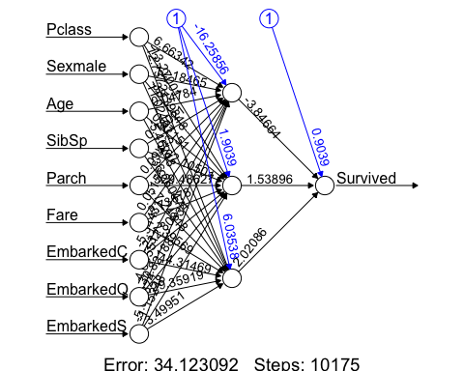

probabilities_05 <- model_05 %>% predict(test.data) %>% as.vector()  
predicted.classes_05 <- ifelse(probabilities_05 > 0.5, 1, 0)  
confusionMatrix(factor(predicted.classes_05), factor(test.data$Survived), positive = '1')

## Confusion Matrix and Statistics  
##   
## Reference  
## Prediction 0 1  
## 0 91 20  
## 1 7 60  
##   
## Accuracy : 0.8483   
## 95% CI : (0.787, 0.8976)  
## No Information Rate : 0.5506   
## P-Value [Acc > NIR] : < 2e-16   
##   
## Kappa : 0.6889   
##   
## Mcnemar's Test P-Value : 0.02092   
##   
## Sensitivity : 0.7500   
## Specificity : 0.9286   
## Pos Pred Value : 0.8955   
## Neg Pred Value : 0.8198   
## Prevalence : 0.4494   
## Detection Rate : 0.3371   
## Detection Prevalence : 0.3764   
## Balanced Accuracy : 0.8393   
##   
## 'Positive' Class : 1   
##

# confusion matrix  
table(predicted.classes_05, test.data$Survived)

##   
## predicted.classes_05 0 1  
## 0 91 20  
## 1 7 60

# The overall accuracy of the test data is 0.8258  
# The sensitivity of the test data is 0.6625  
# The specificity of the test data is 0.9592  
  
# The prediction with hidden layer is similar performance with no hidden layer

# Question 06

model_06 <- neuralnet(Survived ~ ., data = train.data, hidden = 3, err.fct = "ce", linear.output = F)  
plot(model_06, rep = "best")

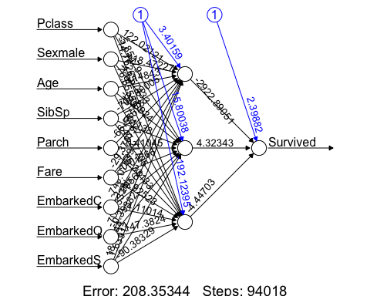

probabilities_06 <- model_06 %>% predict(test.data) %>% as.vector()  
predicted.classes_06 <- ifelse(probabilities_06 > 0.5, 1, 0)  
confusionMatrix(factor(predicted.classes_06), factor(test.data$Survived), positive = '1')

## Confusion Matrix and Statistics  
##   
## Reference  
## Prediction 0 1  
## 0 96 27  
## 1 2 53  
##   
## Accuracy : 0.8371   
## 95% CI : (0.7745, 0.8881)  
## No Information Rate : 0.5506   
## P-Value [Acc > NIR] : 4.907e-16   
##   
## Kappa : 0.6611   
##   
## Mcnemar's Test P-Value : 8.324e-06   
##   
## Sensitivity : 0.6625   
## Specificity : 0.9796   
## Pos Pred Value : 0.9636   
## Neg Pred Value : 0.7805   
## Prevalence : 0.4494   
## Detection Rate : 0.2978   
## Detection Prevalence : 0.3090   
## Balanced Accuracy : 0.8210   
##   
## 'Positive' Class : 1   
##

# confusion matrix  
table(predicted.classes_06, test.data$Survived)

##   
## predicted.classes_06 0 1  
## 0 96 27  
## 1 2 53

# The overall accuracy of the test data is 0.8371  
# The sensitivity of the test data is 0.6625  
# The specificity of the test data is 0.9796  
  
# The prediction with hidden layer is similar performance with no hidden layer